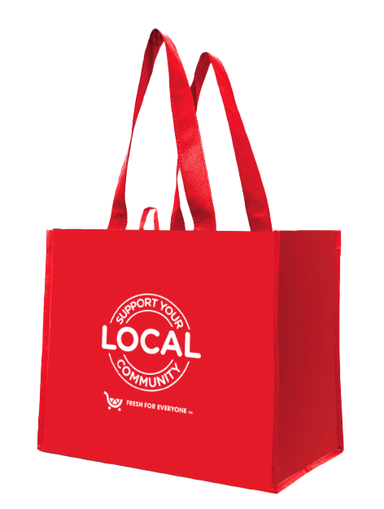

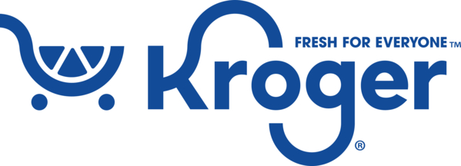

Reminder Email

SUBJECT: We have [insert number of weeks or other time frame] weeks remaining
in the first month of our Kroger Fight Hunger bag program partnership!
PREVIEW TEXT: There’s still time to maximize this opportunity for our cause!

Good morning,
We've reached [or We will shortly reach] the halfway point in the first month of our [insert months] partnership with the Kroger Fight Hunger bag program. This is a wonderful opportunity to raise funds for our organization, spark positive change in our community, and help feed those in need!
Remember, for every $2.50 reusable Kroger Fight Hunger bag purchased at [insert location(s)] this month and next, we'll receive $1. Every bag counts, so let's maximize this opportunity!
Please spread the word to your friends and family. Let's encourage everyone to look for the Kroger Fight Hunger bags in our selected store(s) this month. There’s still time left to make a difference!
For more information about this impactful program, please visit kcolumbus.2givelocal.com.
Thank you for your support!
Best,
[Signature]

