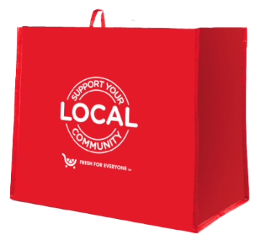

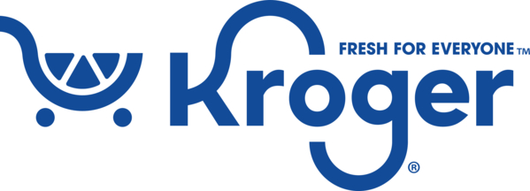

Month 2 Launch Email

SUBJECT LINE: Our second month of the Kroger Fight Hunger bag program partnership starts today!
PREVIEW TEXT: Throughout all of [month 2], our organization will continue to receive a $1 donation for every reusable Fight Hunger bag purchased at our selected Kroger location(s).

Dear [Staff/Board/Volunteers/Supporters],

The second month of our partnership with the Kroger Fight Hunger bag program has officially begun! During [month 2], our organization will continue to receive a $1 donation for every $2.50 reusable Fight Hunger bag purchased at the Kroger located at [address of selected store(s)].

Let’s keep spreading the word! Make sure your friends and family know that supporting [name of organization] this month is as easy as buying a reusable Fight Hunger bag at our selected Kroger. The more people who know to purchase a Fight Hunger bag in [month 2] to support our organization, the greater our donation from Kroger will be.

Thank you for helping us make the most of this opportunity!

Best,
[Signature]

