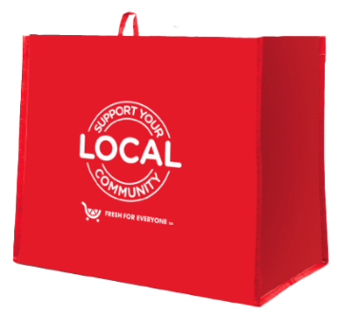
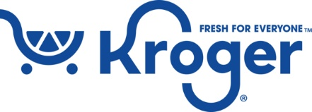

Launch Day Email

SUBJECT: Launch day for the Kroger Fight Hunger bag program partnership!
PREVIEW TEXT: Our partnership with the Kroger Fight Hunger bag program starts today.

Good morning,

Today is the launch day for our Kroger Fight Hunger bag program partnership! Throughout [month 1 and month 2], when you purchase a reusable Fight Hunger bag for $2.50 at the Kroger located at [address(es) of selected store(s)], $1 will be donated to [name of organization].

During this two-month partnership, our goal is to sell [goal of bags bought, e.g., 200] bags, which is equivalent to $[insert donation equivalent, e.g., $200] raised. We are confident that with the help of our dedicated supporters we can reach this goal.

To make the most of this opportunity, we strongly encourage you to share this news with your friends and family. Make sure everyone knows to look out for Fight Hunger bags on display racks in our Kroger selected store(s) this [month 1 and month 2]!

Thank you for your support!

Best,
[Signature]

