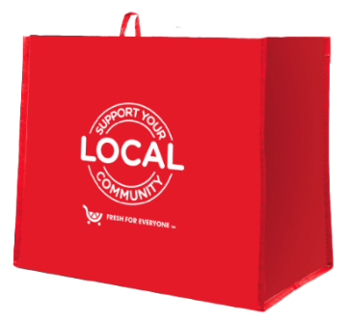
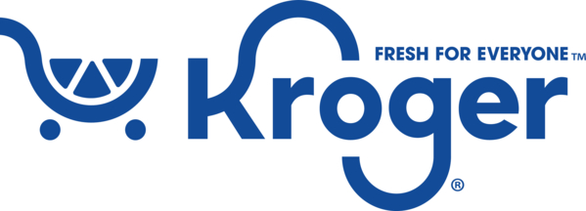

Kroger Fight Hunger bag program

Fact Sheet

Congratulations on your organization’s selection in the Kroger Fight Hunger bag program!

Not sure how to start talking about the program? We’re here to help! We’ve brought together key facts and talking points from across the program website compiled in one place. Below you will find information you can use to discuss this program with your board, staff, and supporters:
- The Kroger Fight Hunger bag program launched on June 1, 2026.
- Kroger operates 116 stores combined across central/northwest Ohio, southeast Michigan, and the Ohio River Valley.
- Designed in alignment with the Kroger Zero Hunger | Zero Waste initiative, the Fight Hunger bag program makes it easy for shoppers to impact local hunger relief efforts and the environment by simply purchasing a durable, reusable bag. A portion of each purchase goes to a local hunger relief organization.
- Every other month, the Store Leadership Team at each Kroger location chooses a local hunger relief organization to be the two-month-long beneficiary of the Fight Hunger bag program. Different nonprofits are selected every two months to ensure the many organizations making a difference in our local communities can be supported by this program. The name of the organization is displayed on the reusable bag rack during their benefiting period.
- Generally, the hunger relief organizations selected by a specific store are within a 10-mile radius of that store location. It’s important to note that this program benefits each store’s regional shopping area.
- From time to time, the Kroger Community Relations Team may select the benefiting hunger relief organizations in support of a special initiative, such as the Feeding America Holiday Campaign and Earth Day.

Page 2

- Each bag costs $2.50, with $1 of that purchase going to support a benefiting hunger relief organization in your community.
- Hunger relief organizations meeting the program's qualifications are submitted to our database of thoroughly researched organizations within the vicinity of each store location
- The bags are made from 95% recycled materials from either nonwoven or woven polypropylene. They are manufactured in Vietnam in factories that follow the strictest guidelines for employment and production standards.

February 11, 2026

