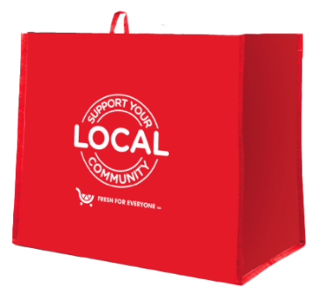
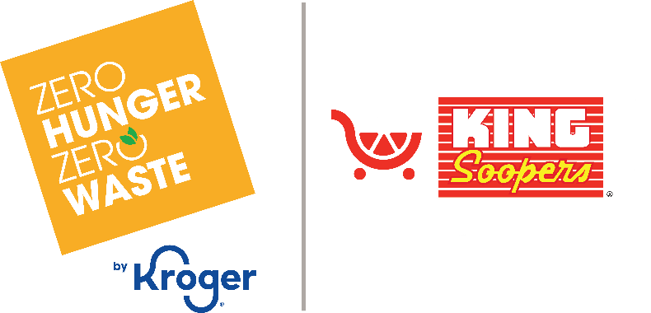

Thank Your Supporters Email & Social Post

SUBJECT: We appreciate your support!
PREVIEW TEXT: Thank you for participating in the King Soopers Fight Hunger bag program.

Good morning,

We are excited to announce that [name of organization] will receive $[donation amount] in donations from our partnership with the King Soopers Fight Hunger bag program during [month 1 and month 2].

Thank you for your participation and support during our benefiting months of the King Soopers Fight Hunger bag program. Whether you bought a bag or helped spread the word, we couldn’t have done this without you!

The money we receive from King Soopers will help us to [share what you’ll do with the donations]. Thank you again for making this a fun and successful experience for [name of the organization].

Best,
[Signature]





Share With Your Followers
Thank you for your support! We are happy to announce that we will receive $[donation amount] from our King Soopers Fight Hunger bag program partnership. Your support helps us continue to make a difference in our community!

